PUNE DISTRICT EDUCATION ASSOCIATION’S
SETH GOVIND RAGHUNATH SABLE COLLEGE OF PHARMACY
SASWAD, DIST-PUNE

Activity Report
Title of the event: National Girl Child Day
Name of activity: Guest Lecture on Beti Bachao Beti Padhao
Date and Day: Tuesday, 21st September 2023 Time: 3.30pm to 4.30pm
Venue: Seminar Hall
No. of participants: 1. Students: 58
2. Staff: 16

The institute has organized a guest lecture on “National girl Child Day” on 24thJanuary 2024 at 03.30pm. under the guidance of Principal Dr. R. S. Chavan. Mrs. Vaishali Kumbharkar, (Member, Masum Foundation, Saswad) delivered the guest lecture. She focused on the declining Child Sex Ratio (CSR) and related issues of women empowerment over a life-cycle continuum. She also encouraged us for women's empowerment in order to improve women status in the country. Mrs.Chhaya Mallav, (Member, Masum Foundation,Saswad) also guided the students on crime against women. Principal Dr.R.S.Chavan also guided the students about girl’s education and its importance. About 58 students and 16 staff members attended the program.
The preamble of this function was delivered by Ms. Sayali Chavan. Principal Dr. R.S. Chavan addressed the students and staff. The program came to an end by vote of thanks by Mrs. Sunita Bathe. The program was coordinated by Ms. Sayali Chavan and Mrs. Sunita Bathe.

Mrs. Sunita Bathe Ms. Sayali Chavan Dr.R.S.Chavan
Co-ordinator Co-ordinator Principal

Photo Gallery
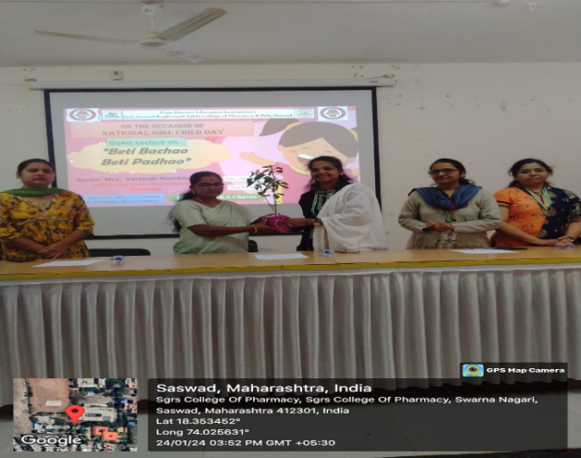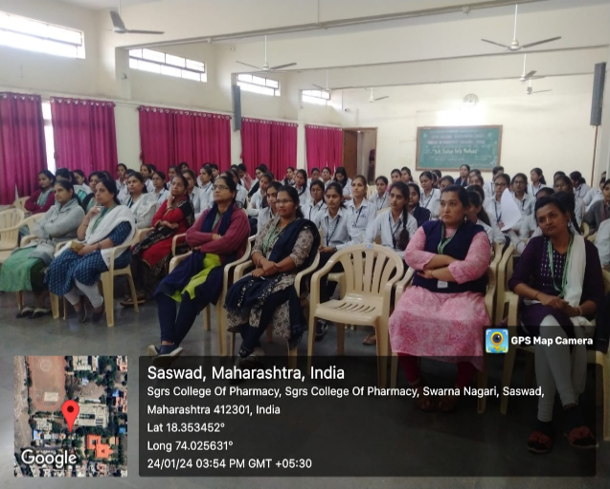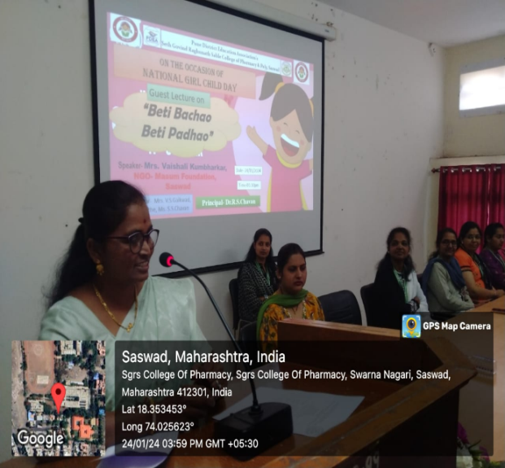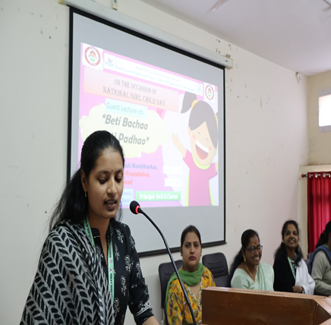
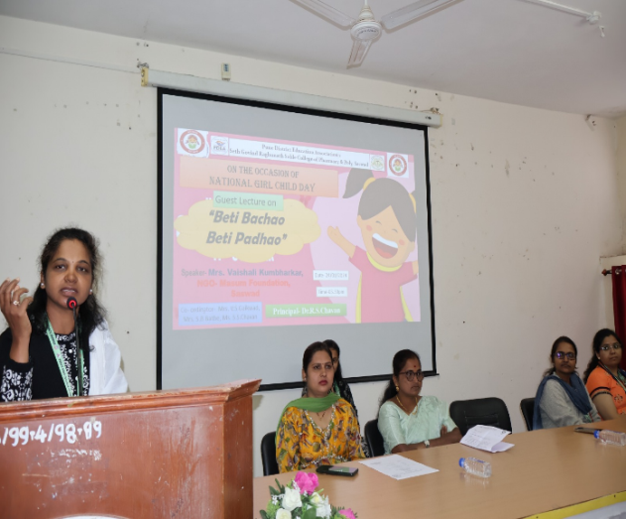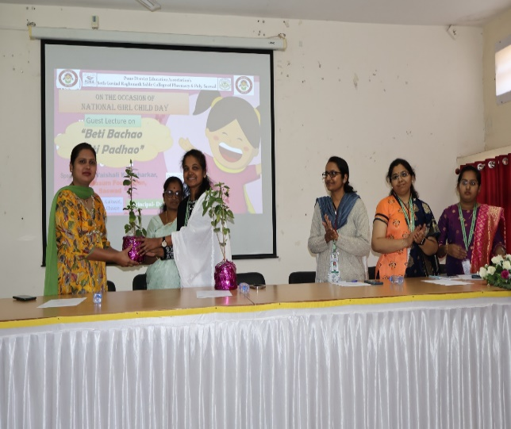

Dr.R.S.Chavan

